Excellent Exam 2 In-Class Practice

Professor: Jonathan Lamb

Please work all the following problems IN ORDER on other paper. Circle final answers. Please show all work for credit.

1.  2.  3. 

4.  5.  6. 

7.  8.  9. 

10.  11. 

12. Find the area enclosed between .

13. Find the area enclosed between the curves  and  displayed below.

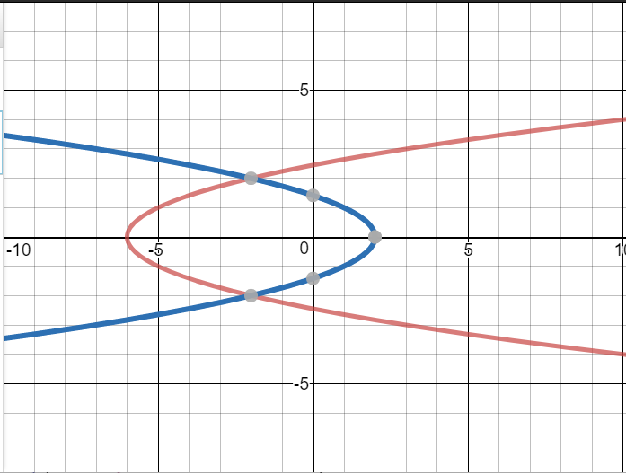

14. Find the average value of  on . Then find the value(s) of x such that  is the average value.

For problems 15-18 the region bounded by the x-axis and the curve  is bounded from x=0 till x=2. Find the volume of the solid of revolution of this region pictured below when it is revolved about the axis of revolution in each of the problems 15-18.

|  |  |
| --- | --- |
|  | 15. Rotate region about x-axis  16. Rotate region about y = 5  17. Rotate region about y-axis  18. Rotate region about x = -3 |